|  |
| --- |
| Date/Location |
| 03/22/2022 @Zoom, 9:30 – 10:30 AM |

|  |  |
| --- | --- |
| Attendees | |
| Client | MAVDEV |
| Joe Saceric | Ammar Lokhandwala |
| Umera Khan | Maria Frausto |
|  | Michael Gurch |
|  | Victoria Sheraden |
|  | Vivian Bui |

|  |
| --- |
| Meeting Agenda |

1. **Current Trello Board**

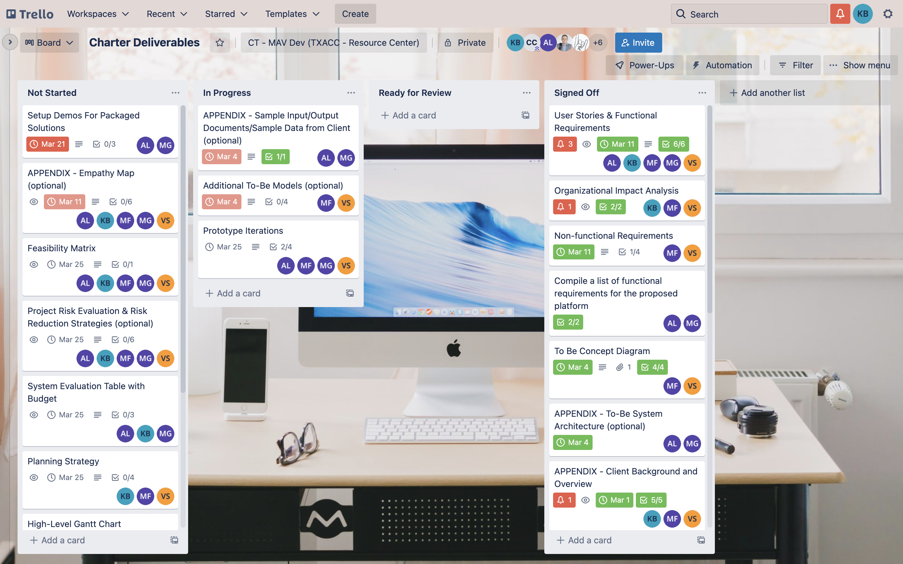

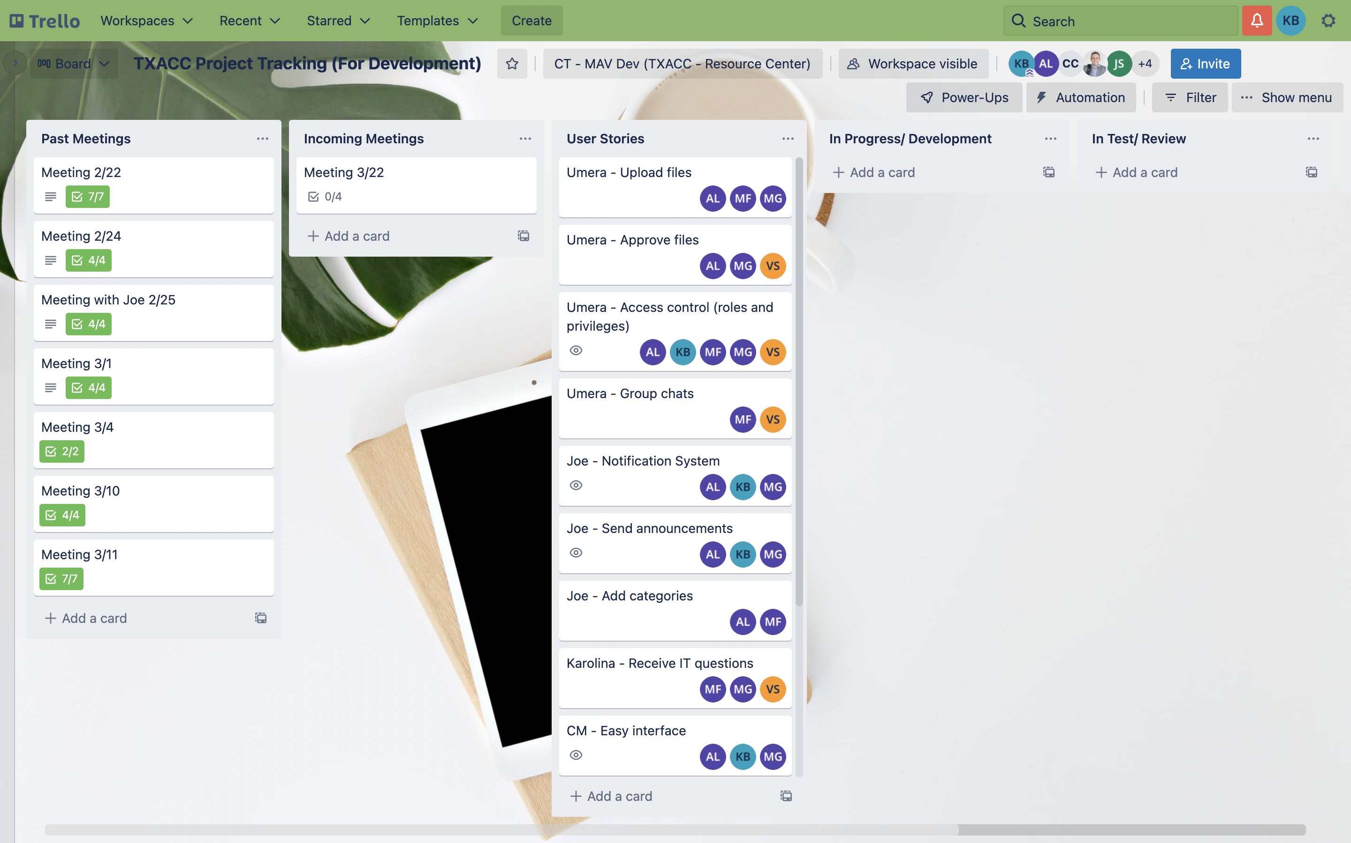

1. **Discussion Agenda**
2. Set up Demo
3. User Stories – TrelloBoard Walkthrough
4. Feasibility Matrix (on Mural)
5. Sprint Kickoff – Planning Strategy (file shared on Box)